### **Questions Answered in This Project**

1. How does total precipitation compare between Seattle and Copenhagen?
2. How does the average daily precipitation compare?
3. How many rainy days total did each city get within the given time frame?

### **Project Overview**

The goal of this project was to compare Seattle’s weather to Copenhagen’s. I used data from the National Centers for Environmental Information (NOAA) to see if there are similarities or differences between the two cities. The dataset includes daily precipitation measurements from January 1, 2018, to December 31, 2022. The main variables in the data are the station name, which identifies the city or airport; the date of the measurement; and the precipitation.

### **Methodology**

To answer the questions above, I followed the standard data science methodology process. First, I focused on understanding the problem by reviewing the project requirements. Next, I collected and explored the data using Python, including the pandas and numpy libraries. I examined both datasets to see how the data was stored, checked for missing values or duplicates, and confirmed that all dates fell between 2018 and 2022. After cleaning the data, I combined the two datasets into a single dataset containing all the information needed for analysis.

Using data manipulation and visualization techniques, I calculated total precipitation, average daily precipitation, and the number of rainy days for each city. I also created charts to help visualize the differences in precipitation patterns between Seattle and Copenhagen.

### **Findings**

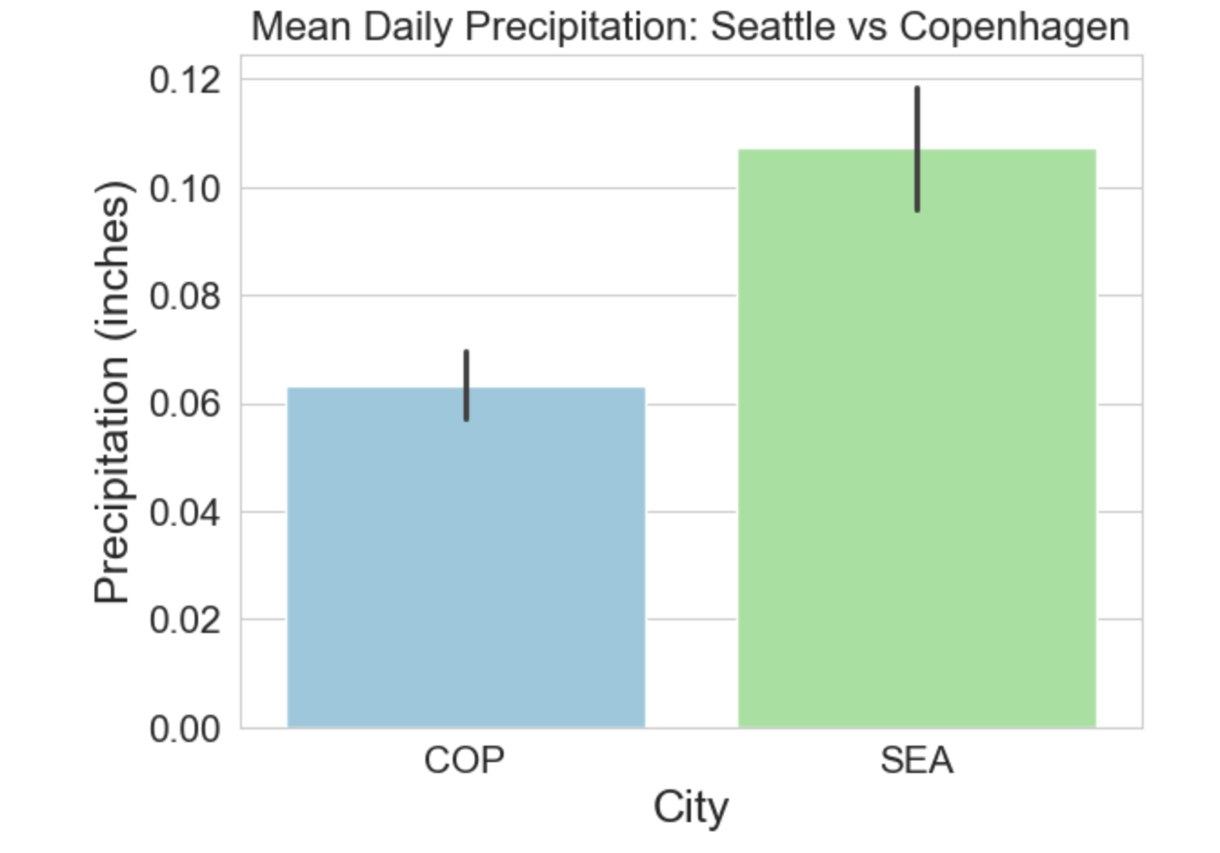

The above chart shows the mean daily precipitation for each city. Seattle’s precipitation is higher than Copenhagen’s, with an average of 0.10 inches per day compared to 0.063 inches per day at the Copenhagen station.

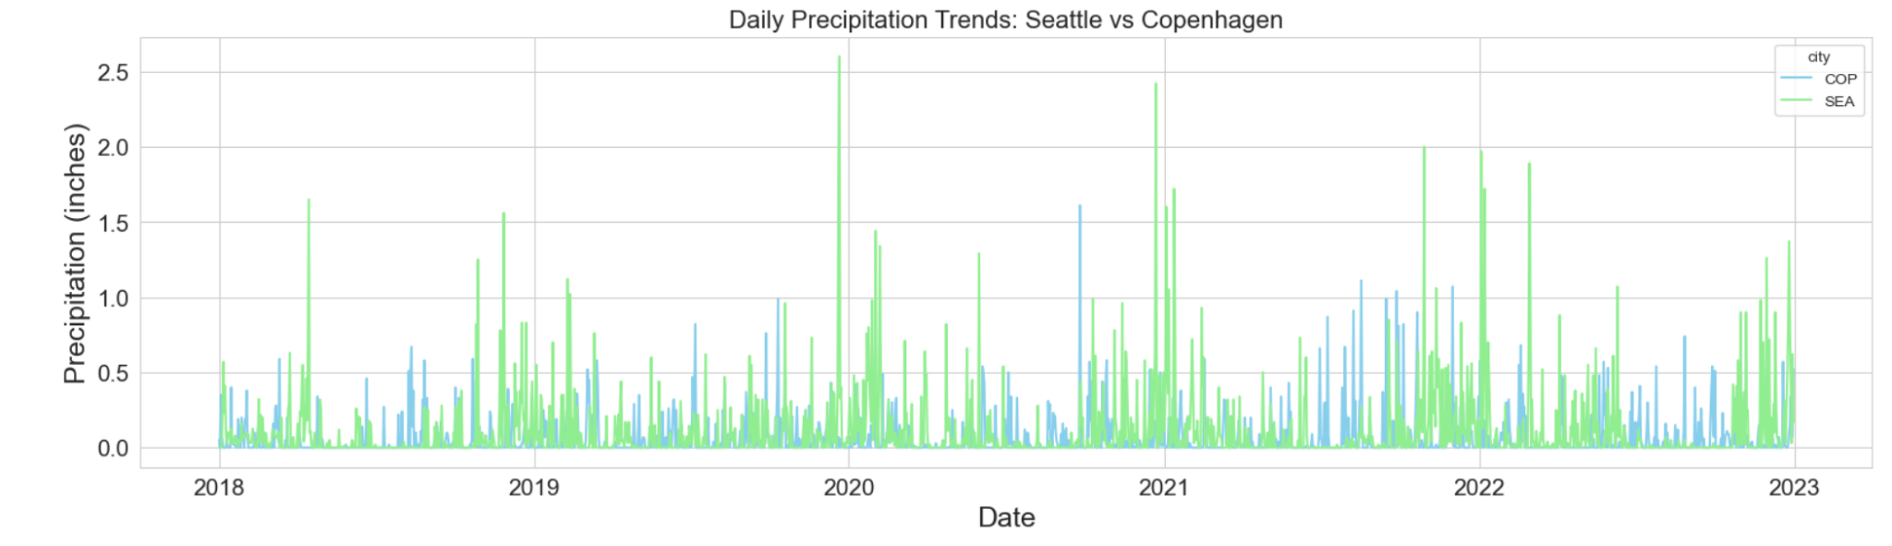

This line graph shows the daily precipitation for both cities from 2018 to 2022. It is clear that Seattle’s precipitation is generally higher. The chart also highlights periods of heavier rainfall and the overall differences in precipitation patterns between the two cities.

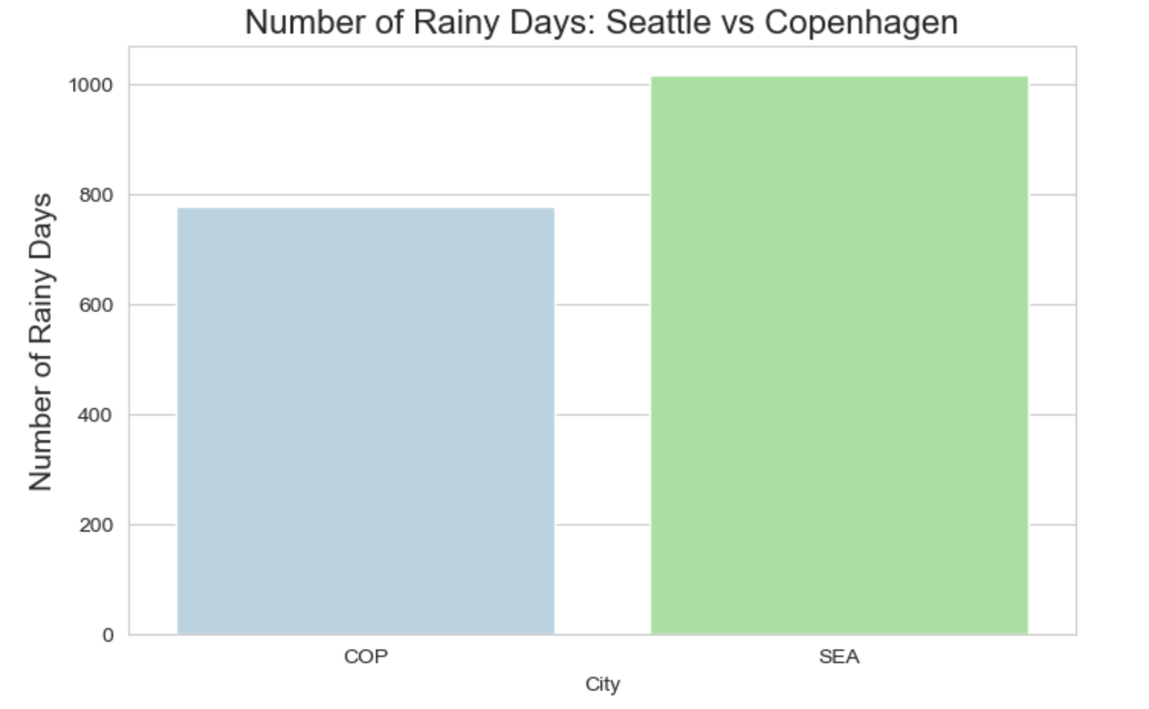

Finally, this chart shows the total number of rainy days for each city from 2018 to 2022. Seattle experienced 1,018 rainy days, while Copenhagen had 777, highlighting that Seattle had more rainfall during this period.

### **Conclusion**

Based on this analysis, the Seattle station received more precipitation and had more rainy days than the Copenhagen station between 2018 and 2022. However, it is important to note that these findings are limited to the two stations analyzed. Other stations or time periods may produce different results. Therefore, these conclusions should be interpreted as specific to the data examined, rather than representative of all locations in Seattle or Copenhagen.